Log in URL = https://etsu.campus.eab.com
Username = your ETSU username (the first part of your ETSU email)
Password = the same password you use to log into Goldink, D2L and email

- Click on the Blue Button “Get Advising” (on the top right hand side)
- What type of appointment would you like to schedule?
- Select Advising
- 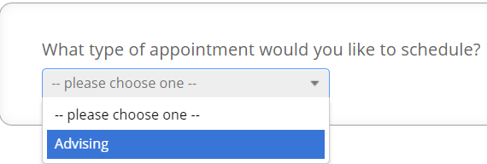

- Select a category
- Select Advising Services
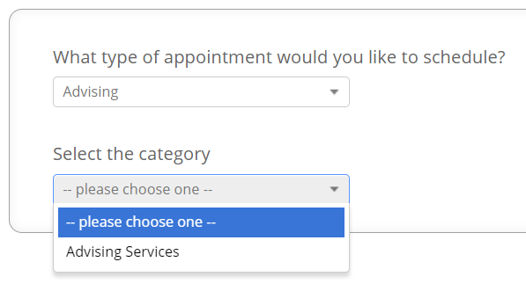

- Select the reason for your appointment
- Select Advising and click NEXT
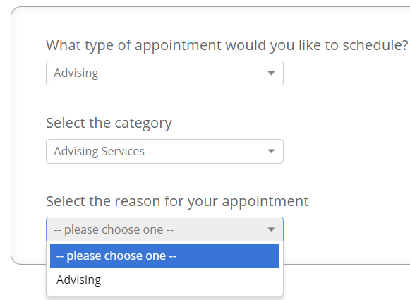
- Select your major, area of concentration or department
- Select Study Abroad
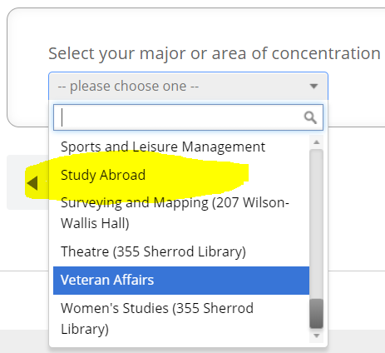

- Select your advisor (or leave blank if you do not have a preference)
- You can leave it blank or select Hopelyn Mooney’
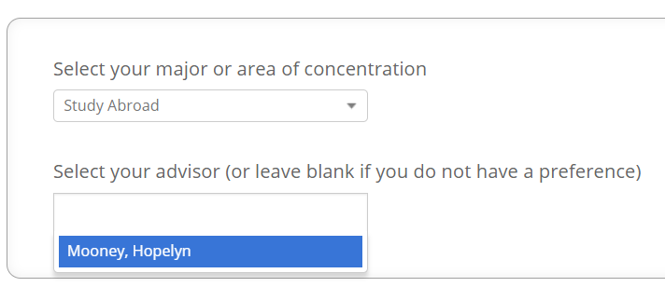

- Click on an available appointment block
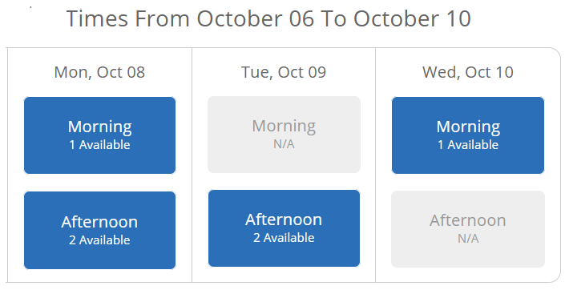

- Click on an available time and click next
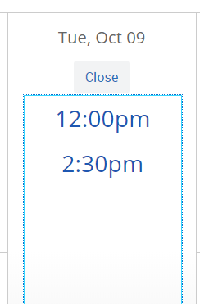

- Enter any comments you would like to add for the advisor.
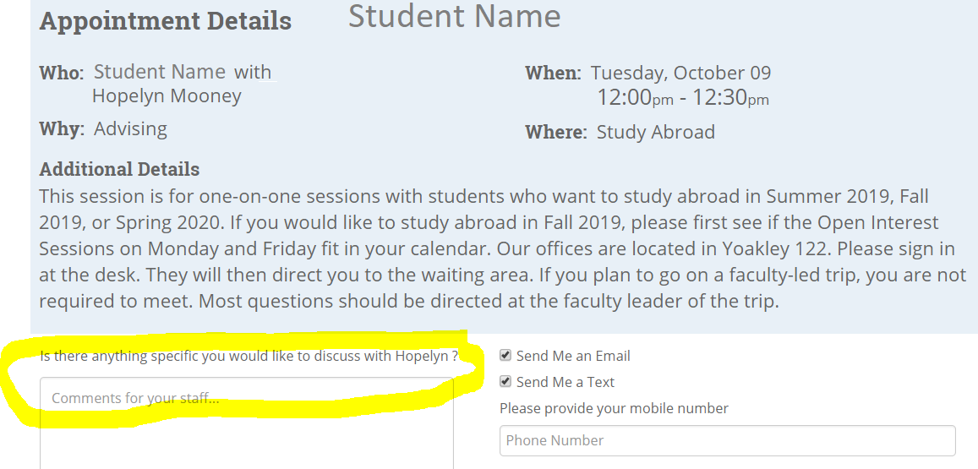

- Click on Confirm Appointment (you will receive an email with your appointment details)

